** Ormiston Medical Practice Newsletter**

Spring/ Summer 2020

Staff News

We now have a new receptionist. Fiona McLeod joined us in late January. We hope you will join us in welcoming Fiona to the Practice Reception team and would ask that please be patient with us as she learns the ropes and settle in the team.

We also have a new GP Trainee. Dr Shahir Chowdhury who started with us in February, following the departure of Dr Galliano. Dr Chowdhury will be with the practice for 6 months as part of his training.

*GP Trainee Doctors are required to complete Video Consultations as part of their training.  This means that during the appointment you and the doctor will be recorded talking to each other. You will receive a consent form from the reception team to complete before your appointment.  Please note that this is not for every appointment and you can choose to accept or decline the option of video consultation.*

Welcome

A big hello to our new Salaried GP Dr Chin Chong. Dr Chong joined us in the beginning of May this year. His working days are Monday and Wednesday all day and alternate Thursday/ Friday All day. Already he has built up an outstanding reputation amongst the patient he has seen.

Appointments

For an on the day appointment, please call at **8am on 01875 610248**. We also offer routine appointments. These have to be booked 2 to 3 weeks in advance. During your consultation, the GP may ask you to make an appointment for 4 weeks time for a review, please make this with the receptionist when leaving the surgery so they can guarantee you a pre-bookable appointment.

If you no longer need your appointment, please call reception at your earliest convenience to cancel. This is to allow other patients the chance to see a health care professional.

Opening Hours

We are open **8.00 a.m. - 6.00 p.m.** from Monday to Friday except on Wednesdays we are closed **1.30 pm - 3.00 pm** then reopen until **6.00pm** This is forregular in-house training and tutorials.

We are closed on Bank Holidays and NHS statutory holidays, and occasional other afternoons for NHS Lothian training. These closures are advertised in advance in the Practice.

Useful Links Regarding Coronavirus

[*https://www.nhsinform.scot/illnesses-and-conditions/infections-and-poisoning/coronavirus-covid-19*](https://www.nhsinform.scot/illnesses-and-conditions/infections-and-poisoning/coronavirus-covid-19)

[*https://www.gov.uk/government/news/coronavirus-update*](https://www.gov.uk/government/news/coronavirus-update)

[*https://www.nhs.uk/conditions/coronavirus-covid-19/self-isolation-advice/*](https://www.nhs.uk/conditions/coronavirus-covid-19/self-isolation-advice/)

Well Pharmacy Ormiston

Well Pharmacy in Ormiston now offers a service to alert you when your prescriptions are ready for collection.

It is a very simple process to go in and advise them of your most up-to-date mobile telephone number. Remember if you change your number to advise both the Pharmacy and the Surgery, this allows us to contact you without any delay.



Carers of East Lothian

Carers of East Lothian (CoEL) focus on supporting carers so that they can continue to care for others. They can provide anything from practical advice to much more support for carers who are struggling to cope with the physical and emotional demands of caring for someone on a full time basis.

They support people who are caring for people with physical health problems, who are elderly and frail or who have learning disabilities. CoEL also have a dedicated support worker who supports people who care for someone with chronic mental health problems.

For more information you can contact them by

Telephone: 0131 665 0135

Email: [centre@coel.org.uk](mailto:centre@coel.org.uk)

There is also leaflets and posters in the waiting area.

Carers of East Lothian (COEL) is running a series of free online events for unpaid carers living in East Lothian to mark Carers Week **2020 (8th to 14th June)**. Carers Week is a national campaign to raise awareness of unpaid carers, the challenges they face and the contribution they make to our communities.



Thank you

All the staff at Ormiston Medical Practice would like to say a huge thank you to all the patients who very kindly handed in Chocolates, Sweets, Biscuits and other delicious treats for us to enjoy over this difficult time.  We can safely say we will be enjoying these goodies well into the year.

Lost and found

We have a lost property box in the Surgery and at the moment we have a mixture of scarves, sunglasses, child’s jacket, child’s handbag, teething soother and a cuddly toy.  Items are often found in the GPs room or the waiting room. If you think any of the property could be yours please ask at reception.

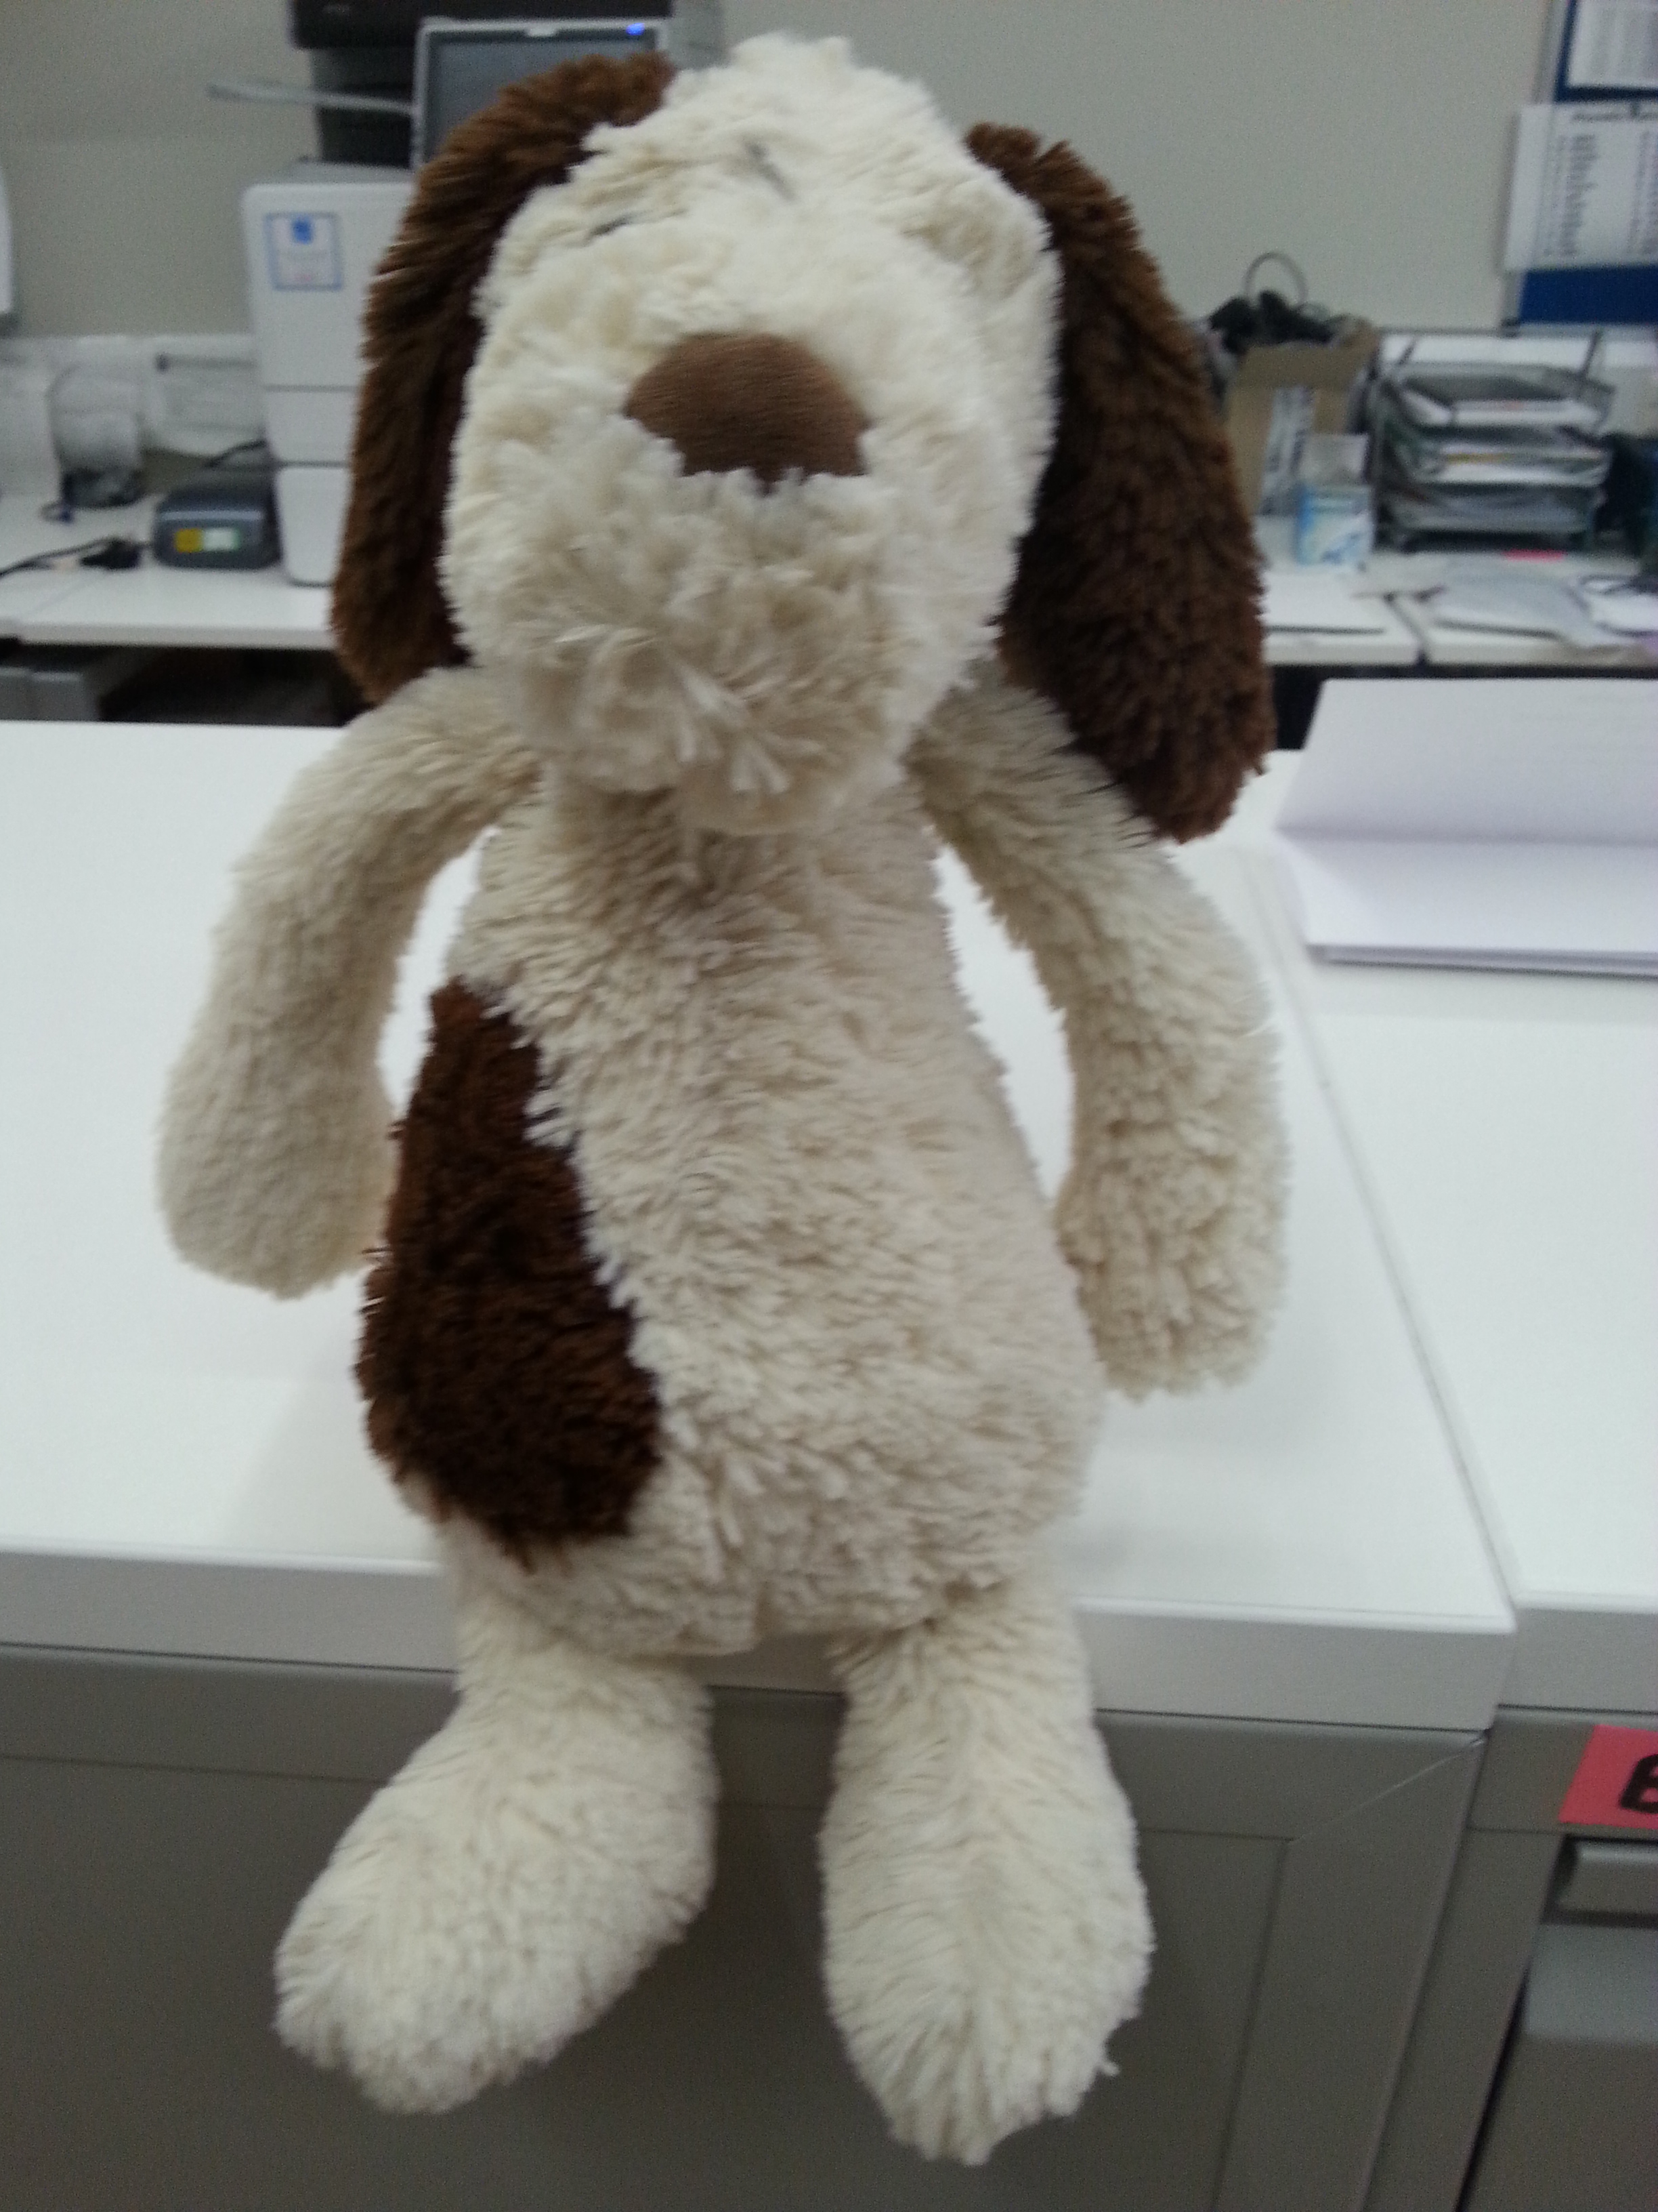

Test Message

We would like to be able to send you practice communications by text message in the future, but first we need your permission so please let us know if you would like to give consent to contact you this way or not.